**DBMS ASSIGNMENT 1:**

**Create the following tables:**

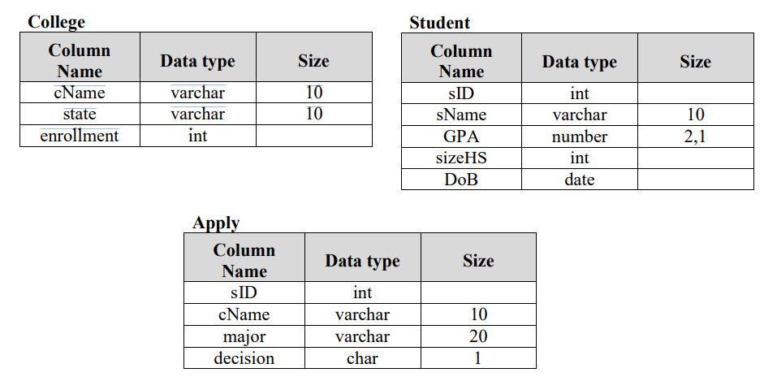

First one is Student that contain information of student such as ID of Student, his name, GPA that he/she scored, size of his High School class i.e., number of students in his/her high school class and student’s Date of Birth. Second table in database is College this table contains college information such as name of college, state where it is situated, and its enrolment i.e. number seats in that college. Third table contains data about applications and this table is named Apply each row of this table will contain information about one application. Each application has

• sID: This will contain ID (similar to Roll No.) of student who is applying. [Each Application only contain sID of Applicant all other information about student such as his name or GPA can be check from Student table]

• cName: Name of college where applicant is applying [similar to sID all the other information about college such as its state or enrolment can be retrieve from College table]

• major: it is the major in which applicant is applying e.g. CS, EE, biology etc. •decision: it is Y or N shows Acceptance or Rejection of Application

Solution:-

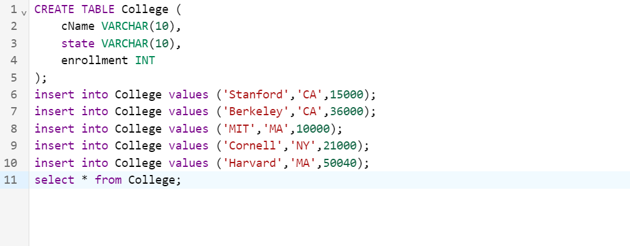

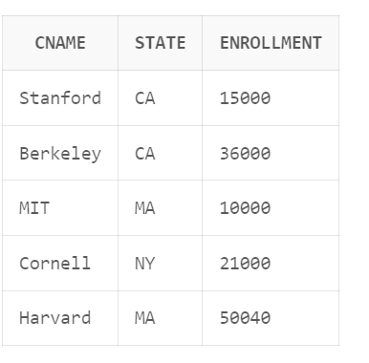

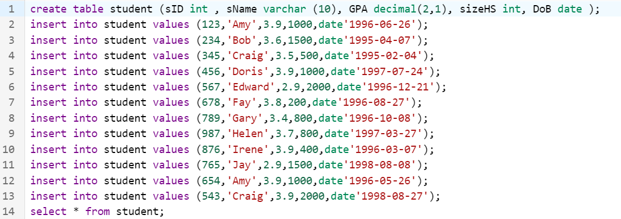

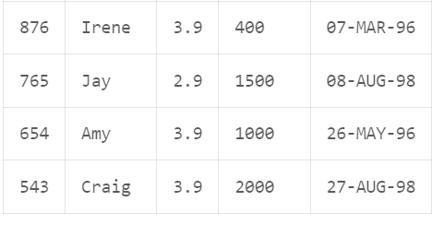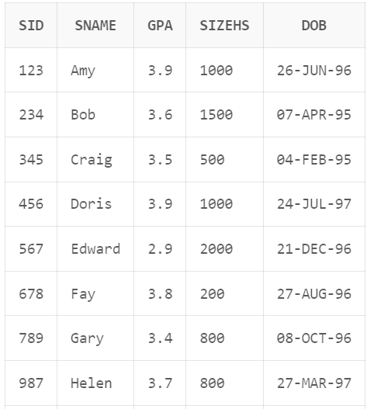

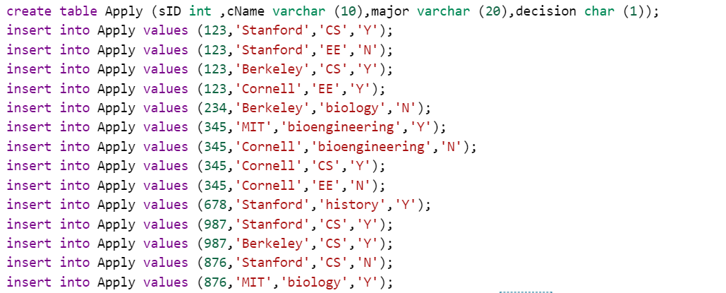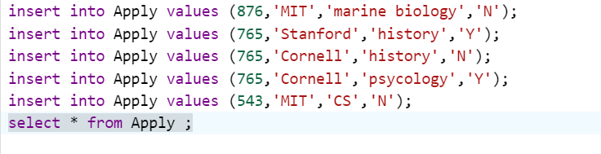

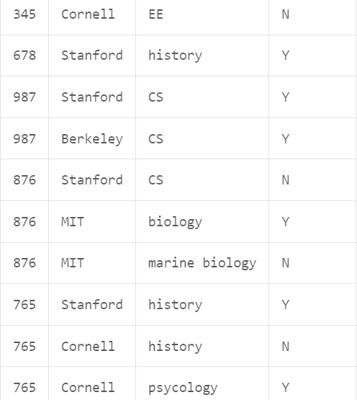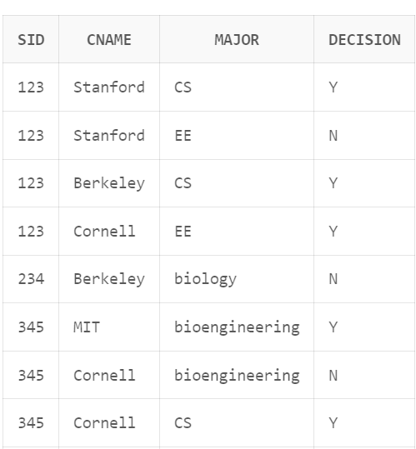

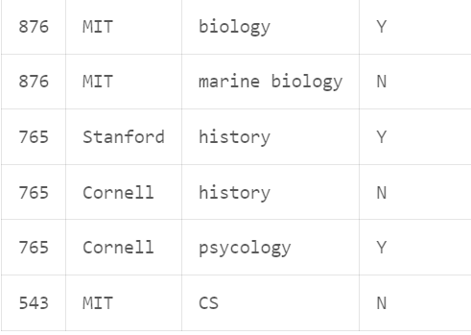

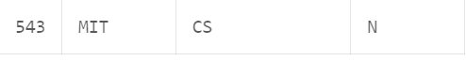

**State of the SQL * PLUS Queries for each of the following:**

1. List the student’s name, dob from student table

select sName,dob from student;

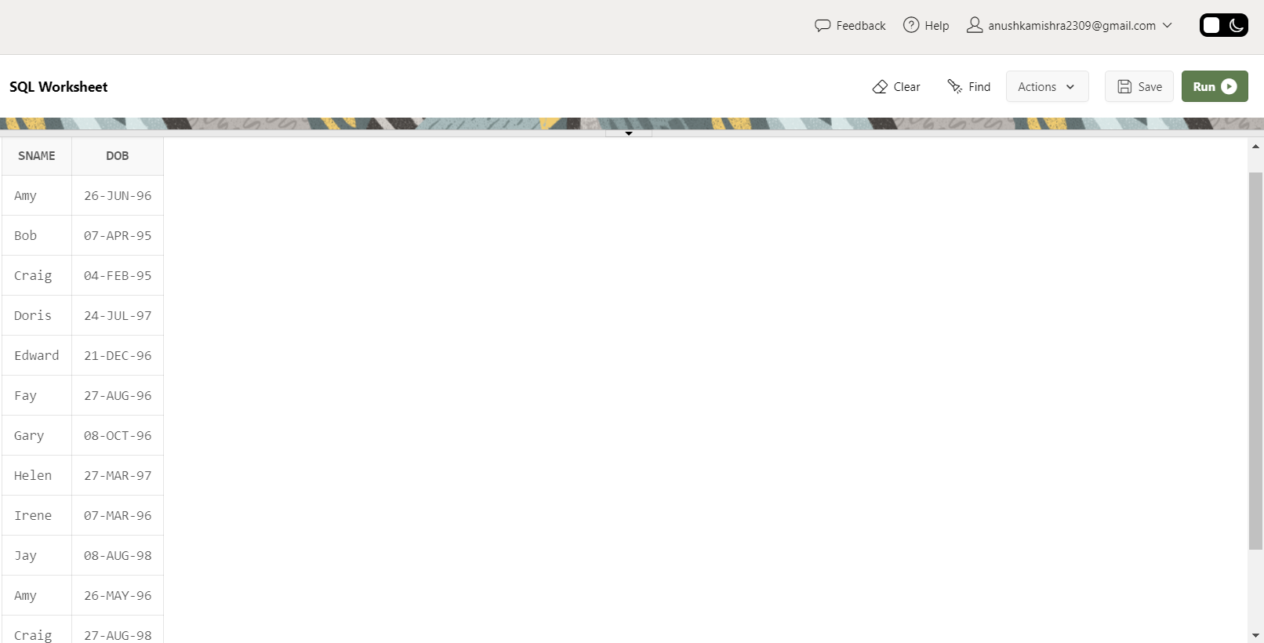

1. List the name of student scoring more than 3.7 in GPA.

select name from student where gpa>3.7;

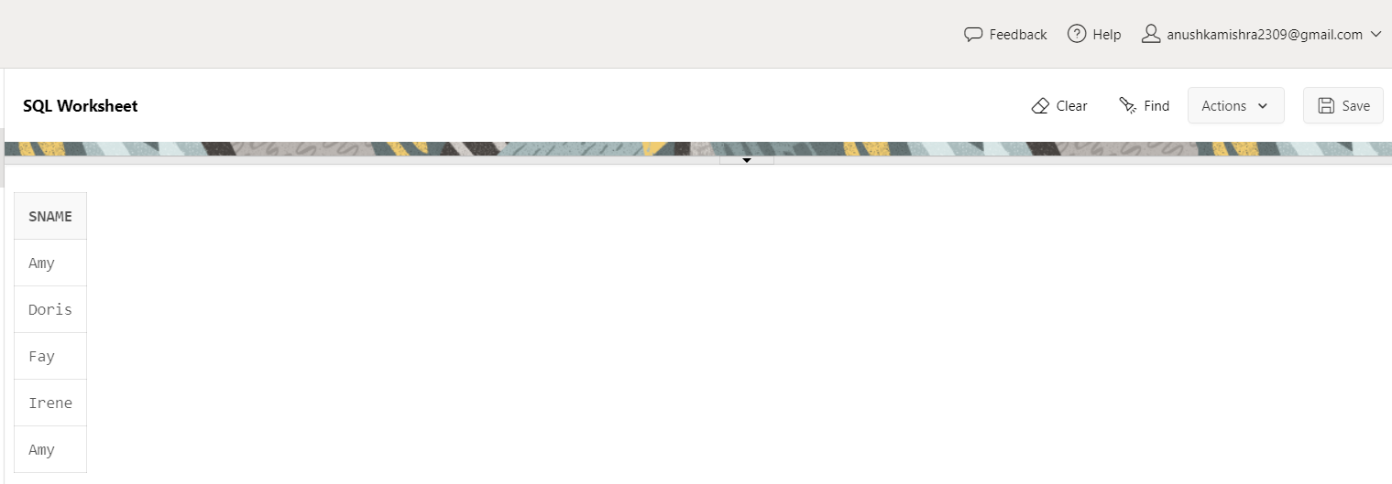

1. List the name of student whose High School size is at least 1000 and born after 1996. [Hint: check DoB greater than 31st December, 1996]

select sName from student where sizeHS>=1000 and DoB>TO_DATE('1996-12-31','YYYY/MM/DD');

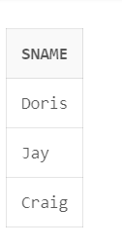

1. List the name of student who are scoring GPA in between 2.9 and 3.9

select sName from student where GPA between 2.9 and 3.9;

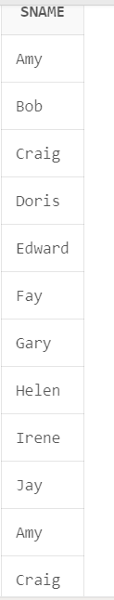

1. List all the details of colleges who situated in MA.

select * from college

where state= 'MA';

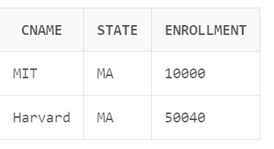

1. List the students who are scored more than 2.0 but less than 3.5.

select * from student

where GPA>2.0 and GPA <3.5;

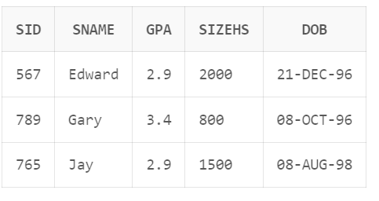

7. List the students who have born after 1st Jul 96 in the order of the Date of Birth.

select * from student

where DoB>date'1996-07-01';

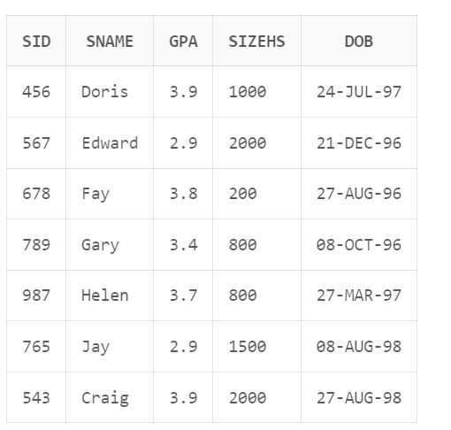

8.List the sID, cName, decision of applications that are accepted.

select sid,cname,decision from apply where decision='Y';

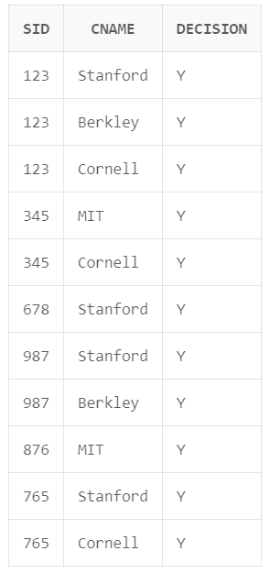

1. List the sID, cName of applications which are filled at Stanford.

select sid,cname from apply where cname='Stanford';

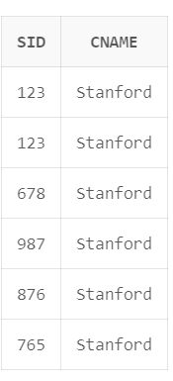

1. List the colleges that that has enrolment greater than 10001.

select * from college

where enrollment>10001;

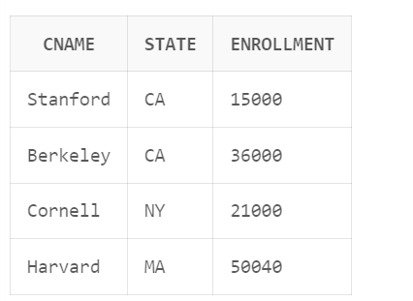

1. List the colleges not in California.

select * from college where state<>'California';

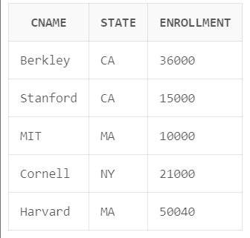

1. List names of all student who came from high school having size greater than 17000 and scored GPA less than 3.8.

select * from student

where sizeHS >17000 and GPA <3.8;

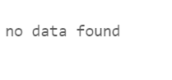

1. Display the description of the student table.

desc student;

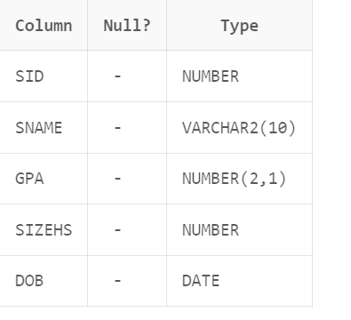

14. Display the details of all students.

select * from student;

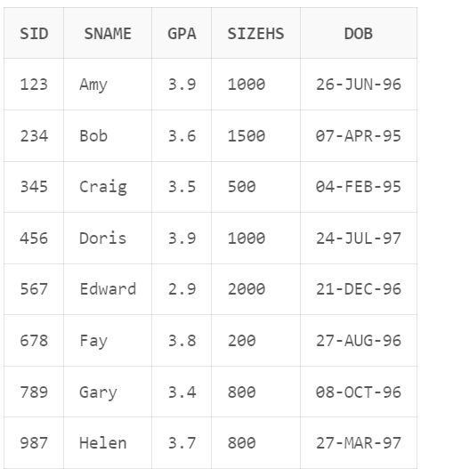

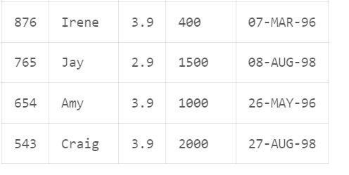

15.Display unique majors

select distinct major from Apply;

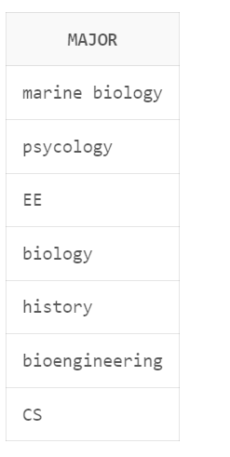

16. List the student names those are having three characters in their Names.

select sName from student where length(sName)=3;

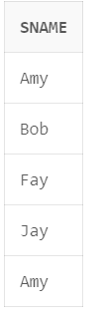

17. List the student names those are starting with ‘H’ and with five characters.

select sName from student where sName like 'H%';

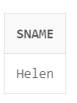

18. List the student names those are having third character and fifth char. must be ‘e’.

select sName from student where sname like '__e_e%';

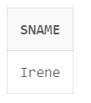

19. List the student names ending with ‘y’.

select sname from student where sname like '%y';

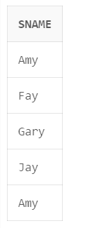

20. List the Students in the order of their GPA.

select * from student

order by GPA;

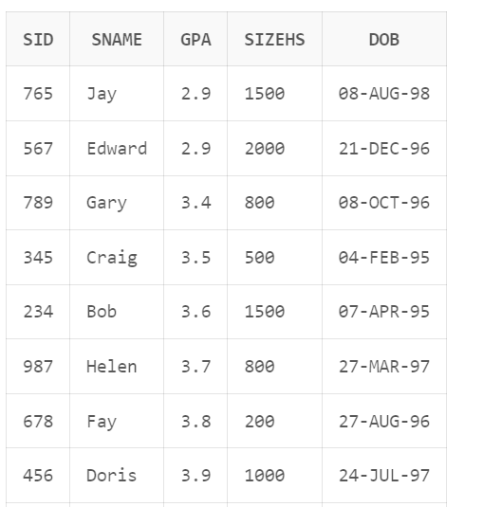

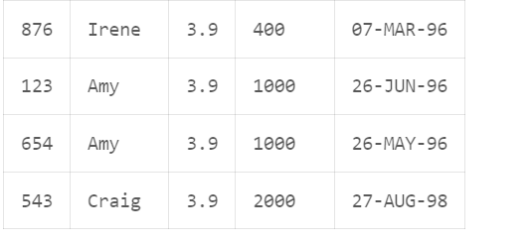

21. List the details of the students in order of the ascending of GPA and descending of DoB.

select * from student

order by DoB DESC;

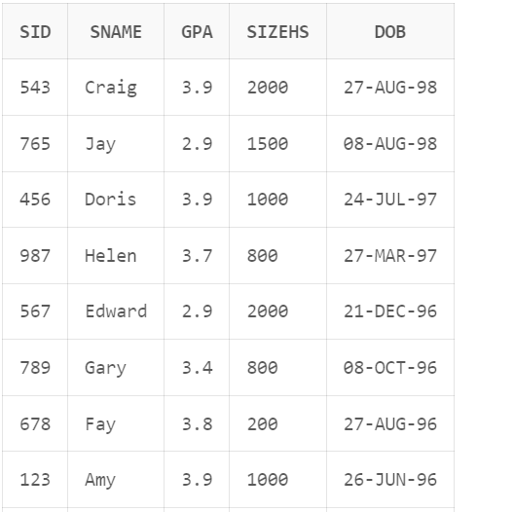

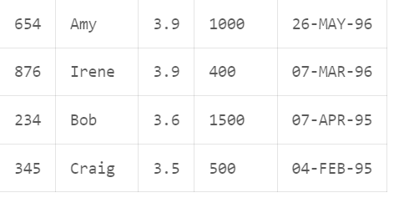

22. List the sIDs of student who apply in either ‘Stanford’, ‘Cornell’ or ‘MIT’ college.

select sid from apply where cname='Stanford' or cname='Cornell' or cname='MIT';

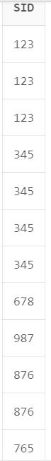

23. Delete all applications filled at Stanford (Choose table wisely)

delete from Apply

where cName ='Stanford';



24. Delete the college Stanford from college table.

delete from college

where cName = 'Stanford';

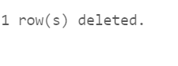

25. Modify the GPA of all students by giving 10% raise in their GPA.

update student

set GPA = GPA + (GPA* 10.0 / 100.0);

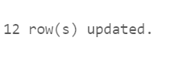

26. Increment the GPA of the students by 1.5 whose GPA is less than 3.5 and belongs to High School having size greater than 1500.

update student

set GPA= GPA +1.5

WHERE GPA <3.5 and sizeHS >1500;

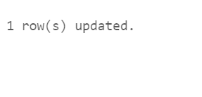

27. Delete the students who have scored less than 3.2 GPA.

delete from student

where GPA <3.2;

